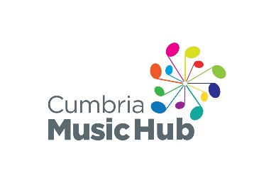
Carlisle Music Centre
Please email your completed form to shona.wilson@cumbria.gov.uk

Which Music Centre Group(s) would you like to join?
- Junior Concert Band
- Youth Concert Band
- Strings
- Guitars
Student Details
Name:
Date of Birth:
School:
Contact Details
Parent / Guardian Name:
Address:
Post Code:
Email:
Student Email:
Contact Phone Number:
Instrument Details
First Instrument:
Level of achievement:
Second Instrument:
Level of achievement:
Instrumental Teacher(s):

Medical and Emergency Details
Emergency Contact Telephone 1:
Relationship to student:
Emergency Contact Telephone 2:
Relationship to student:
Family Doctor Name:
Family Doctor Telephone:
Does your child have any medical condition, allergies or recent illness we should know about?
Is there anything else you would like to make music centre staff aware of?
Photography Consent
We plan to take photos and/or videos for Cumbria Music Hub promotional use. No players will be identified by name.
I understand and agree to the above
I do not agree
Contact Permission
We may occasionally want to get in touch by email to let you know about events organised by Cumbria Music Hub.
Yes please, I'd like to hear about Cumbria Music Hub events
No thanks
Annual Fee
First Child: £48
Second Child: £30
Third Child: £25
https://cumbriamusicservice.co.uk/music-centre-payment-form/

View the full Cumbria County Council Privacy Policy

